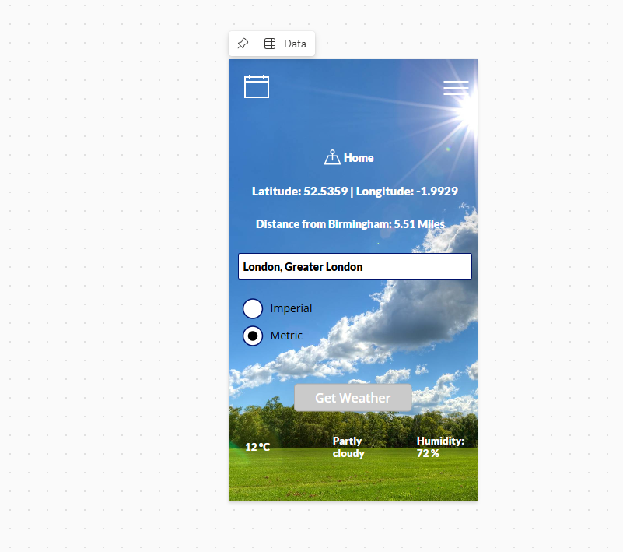
Latitude and longitude from equator – accurate coordinates based on users pinpoint location, optional feature not main, automatically changes based on user location.
Distance from Birmingham shows the users exact miles from Birmingham which changes based on their location, optional feature
Metric and Imperial units of measure – when city specific data is entered users have the option to see weather in Imperial or Metric measures, optional feature – UX design specific
GetWeather button allows users to enter a specific city around the world with information in the text box showing the city and county – Optional feature, previous plans of showing city + county + country etc – could be future changes for development

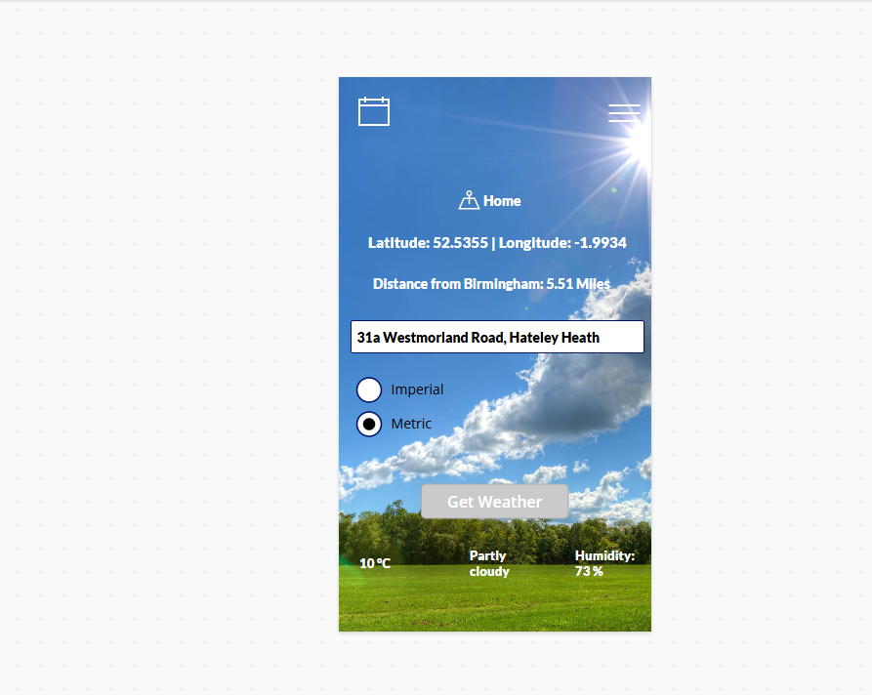

Location enabled setting allows users to see exact location when loading the app instead of manually typing cities in input. This shows pinpoint location automatically with the weather data also being shown automatically. Users can still manually type for cities across the world in the box and fetch data from it.
Changes automatically when in different locations, from the screenshot is shows exact coordinates in west Bromwich but would show exact coordinates based on where the user is.

